**COSC422 Assignment 2 Report**

**The Scene**

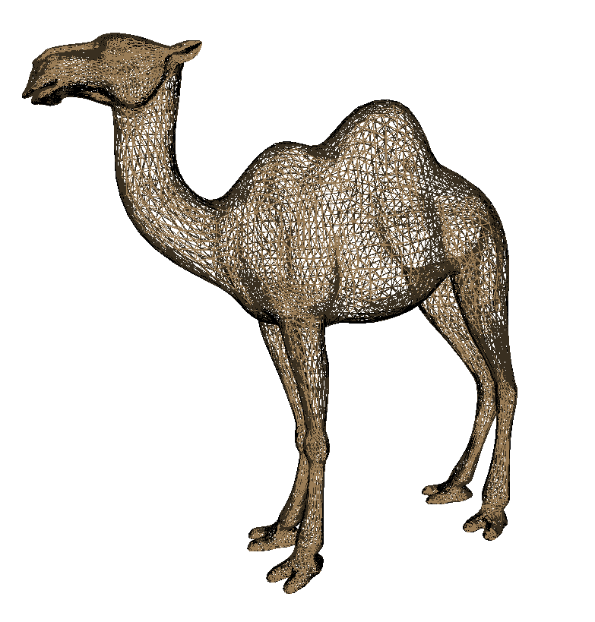

Figure 1 - Wire mode + Zoom

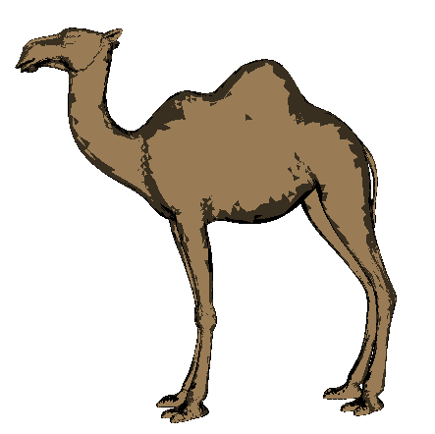

Figure 3 - Two-tone shading - view 2

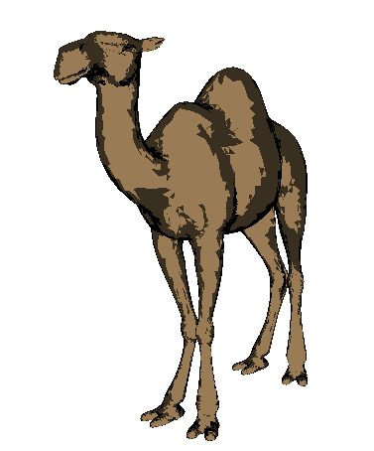

Figure 2 - Two-tone shading - view 1

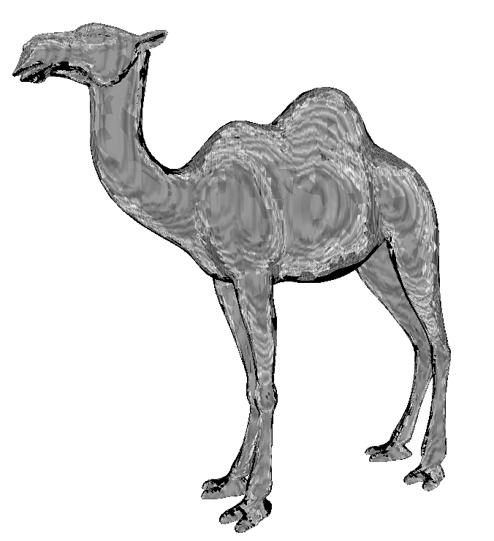

Figure 5 - Pencil shading - 5 textures & blending

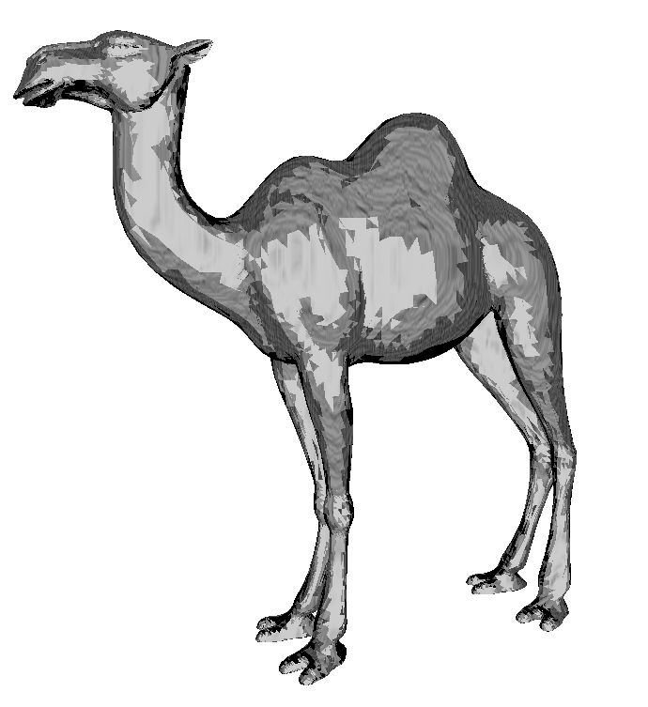

Figure 4 - Pencil shading - 3 textures

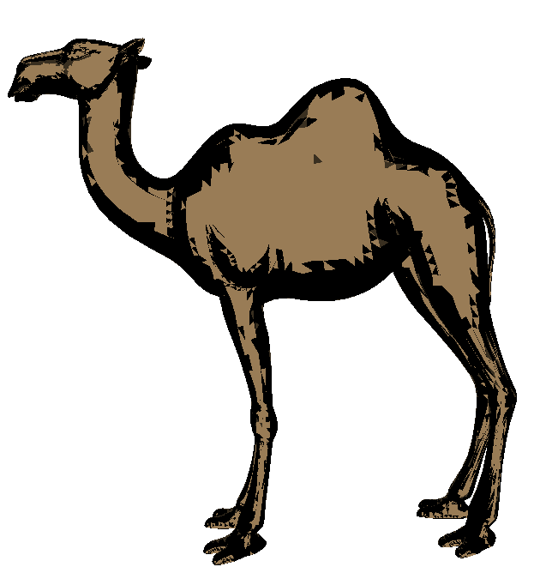

Figure 6 - Edges - thick

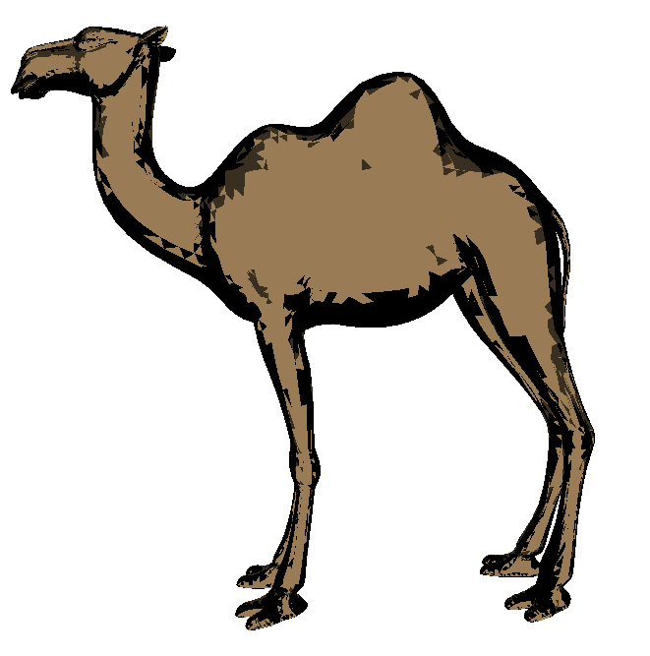

Figure 7 - Edges - thin

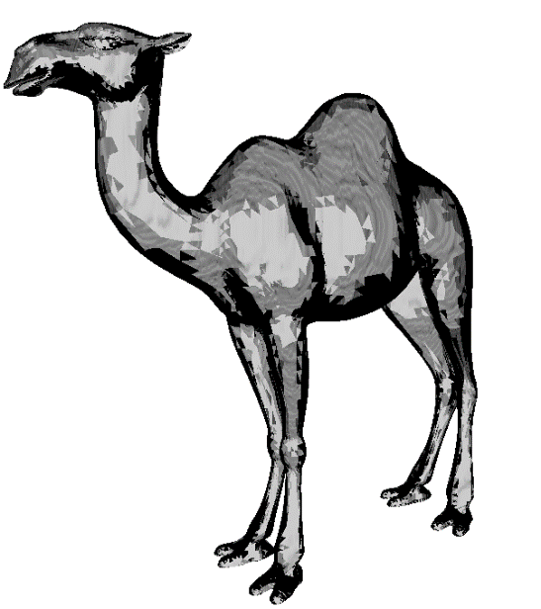

Figure 8 - Edges - Pencil shading

**Basic NPR**

1. **Two-tone shading:**

Figure 1 shows the model being in a wireframe mode.

Figure 2 & 3 shows Two-tone shading. i.e there are only two colours outputted.

1. **Pencil shading:**

Figure 4 shows the model shaded with 3 different textures.

Figure 5 shows the model shaded with 5 different textures and blended using textured weights.

To load the textures, the devil library is used.

1. **Geometry shader:**

Modified Algorithm to be able to use triangle adjacency in the Geometry shader.

Using **triangles**_adjacency primitive type instead of **triangles.**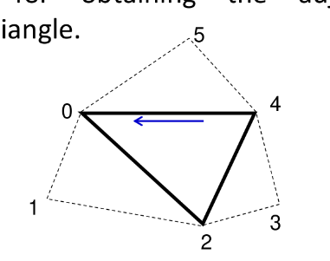

**triangles**_adjacency primitive now has 6 elements.

1. **Silhouette and crease edges**

Comparing the centre face normal with the others. This is illustrated in the diagram below and the code snippet.

If there is a gap, fill it with the color black. Varying levels using keys described below.

**Extra features**

1. **Texture Weighting & Blending**

Blending the two textures using an arbitrary weight “t” that corresponds to the diffTerm.

**Control Functions**

|  |  |
| --- | --- |
| ↑  Rotate Under | 'q'  Increases thicknesses of silhouette & crease edges |
| ↓  Rotate Over | 'a'  Decreases thicknesses of silhouette & crease edges |
| ←  Rotate Right | 't'  Toggle texture weighting & blending |
| →  Rotate Left | 'f'  Wireframe mode |
| Spacebar  Toggles between Two-tone & Pencil shading | 'ESC'  Exit application |
| Page up  Zoom in |
| Page Down  Zoom out |

**Compiling & Running Application**

On a Linux Machine, on the Makefile level, type: ‘make && make program’

**References to Sources**

* All Models and Textures used were from the lab and lectures.